Summer of Exploration 2025

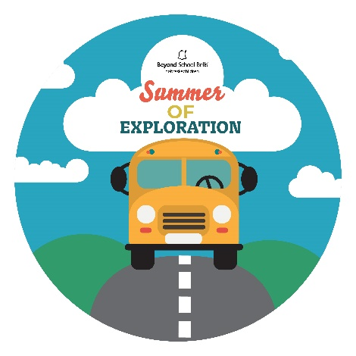 Request For Proposal

Summer Grant Details:

* **Applications up to $15,000 due to BSB by March 28th**
* Eligible applicants
  + 21st Century Community Learning Center sites
  + School-based Summer ELO programs for school-age youth
  + Community-based Summer ELO programs for school-age youth
* Application materials
  + Completed application form including detailed budget
  + Detailed plan incorporating at least one Student-Centered Learning approach:
    - Youth Voice and Choice
    - Community-Connected, Age-Appropriate, Real-World Learning
    - Foster Lifelong Learning and Pursuits
  + Required letter of support from superintendent or principal
* Reporting and evaluation requirements
  + All awardees must provide a general ledger along with expenditure reports by the 15th of each month
  + All awardees will be required to complete a final progress report via Qualtrics by September 30th, 2025.
  + All awardees will be required to complete at least one Summer Storytelling Template (BSB will provide template) by September 30th, 2025.
  + All awardees are required to facilitate Youth Brainstorming to document Youth Voice during the grant period (BSB will provide a packet with all materials).
* Demonstrated sustainability
  + Applications must detail a plan for sustainability, through fostering partnerships, building program awareness, securing funding, or other strategies.
  + Applications must demonstrate local support – monetary, in-kind, and/or donations of time and talent.
  + All awardees are required to incorporate family engagement strategies into their application and sustainability planning

Grant applicants should incorporate the following in their programming proposal:

* Plan for Youth Brainstorming sessions to be facilitated, reported on, and incorporated into programming
* Details aligning your ELO program with your district’s goals for summer experiences that complement but do not duplicate school-year activities
* Engagement in community-based learning – bringing in community expertise and getting youth out into the community for service-learning projects and activities
* Should include, where possible, STEM, including Tech and other tool-rich experiences; connections to future learning / careers; support for student and staff wellbeing; activities that get youth outdoors and moving

Ideas for a successful application:

* Tap into BSB Centers of Excellence for guidance / advice / strategies
* Use BSB Curriculum / Toolkit to facilitate programming and engage your community
* [Wallace Foundation Summer Learning Toolkit](https://wallacefoundation.org/toolkit/summer-learning-toolkit)
* Engage older youth as leaders and mentors in programming, HS Students as club facilitators, College students as content experts; CTSO clubs as partners
* Utilize BSB’s [STEM Family Engagement](https://beyondschoolbells.org/projects/family-engagement.html) resources
* Reach out to BSB for questions, collaboration, or advice

Evaluation Requirement

* Required progress and narrative reports due to BSB on or before September 30th, 2025. Qualtrics links will be shared directly with awardees.
* At least one evaluation storytelling project around a summer experience at your program
* At least one youth-directed evaluation such as Youth Videography, Student-authored summer story book, Youth Voice Brainstorming sheets, etc.

Reach out to Dakota Staggs, [dstaggs@nebraskachildren.org](mailto:dstaggs@nebraskachildren.org) and [apearson@nebraskachildren.org](mailto:apearson@nebraskachildren.org), or your BSB point-person with questions or concerns. We look forward to hearing from you!