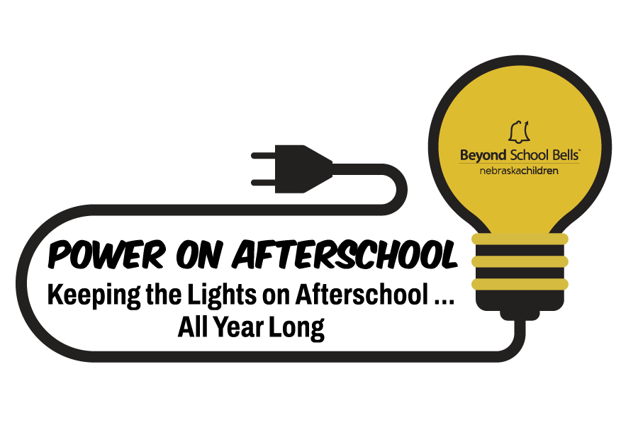
Power on Afterschool-April 2026
Funding for an Afterschool Appreciation and Advocacy Event

APPLICATION

Request for Event Reimbursement
Deadline: February 20, 2026
Beyond School Bells at Nebraska Children and Families Foundation is pleased to provide reimbursement to afterschool sites for expenses associated with hosting an afterschool program appreciation event during the month of April as part of Power on Afterschool: Keeping the Lights on Afterschool All Year Long.
April’s Power on Afterschool activity is a people-centered, low-lift advocacy opportunity that celebrates staff (in conjunction with Afterschool Professionals Appreciation Week), youth, families, and partners while showing why afterschool matters right now! This effort also keeps the momentum going towards October’s Lights on Afterschool.

Submission of Application and Questions
- Submit the application by email to Patricia Sanchez-Stewart at psanchezstewart@nebraskachildren.org no later than Friday, February 20, 2026.
- Questions may be directed to Patricia by email or by phone at 308-325-5438

Applicant Information

Name of Program or Organization and City
Contact Person:
Contact Person Title:
Contact Email:
Total Funding Amount:
Anticipated Date of Event:
Name of Person Coordinating the Event:
Anticipated number of participants who will benefit from the activity or event:
Power on Afterschool Questions

Describe the activity, event or project you plan to host in April:

How will you help “keep the lights on afterschool” by sharing your program’s story with families, school leaders, stakeholders and the broader community?

Have you attended a Power on Afterschool monthly learning session in the months of November, December, January or February?

Yes, I have attended a session. Sorry, I have not attended a session.

If no, would you like to join the Power on Afterschool Learning Community? Sessions occur once a month for 30 minutes at 12:30pm. Next session is on February 10 at 12:30pm via Zoom.

Yes, I’m interested. Send me the Zoom invite. Sorry, I’m unable to participate.

If yes, share what Power on Afterschool strategies or actions you have been able to incorporate into your afterschool program:

Last October, the Afterschool Alliance released findings from America After 3PM, sharing insights into how kids spend their time after school, who is participating in afterschool programs, and the challenges families encounter. Nebraska-specific data was included in the release.

How will you use America After 3PM or Nebraska After 3PM data during your April event to show families, partners and policymakers why afterschool programs are essential in your community?

Power on Afterschool Focus Areas
Which of the following focus areas do you plan to incorporate into the Power on Afterschool event in April? Please select one or more and answer the questions for each focus area.
Advocacy
Which advocacy actions will you include?
How many policymakers or community leaders do you plan to engage, and how?

Partnership and Sustainability
In what ways will this event help build long-term sustainability for your program?
What new relationships do you expect to establish?

Youth Voice
How will you incorporate youth voice or input?
How will youth participate in planning, leading or presenting at the event?

Family Voice
How will you incorporate family voice in your event, and how will you collect and apply their feedback?

Staff Empowerment and Innovation
How will staff be empowered to contribute, create or innovate during the event?

Celebration and Recognition
How will your event celebrate youth achievements, staff contributions or community support?
How will you recognize staff during the month of April or week of Afterschool Professionals
Awareness Week?

Awareness and Storytelling
How will you share your afterschool story as part of the project?
Who is the targeted audience of your afterschool story?

Event Budget

Budget – Describe what you plan to spend for the event?
Expense Categories | Amounts | Explanation for Expense
Wages (direct personnel)
Benefits
Travel
Supplies
Training and Outreach
Contract/Consulting
Other Expenses
 | TOTAL: $

Agreement

I agree to the following:

Provide Beyond School Bells 2-3 photos of event with media permissions

Complete a narrative report via a Qualtrics link provided by Beyond School Bells within 10 days of the event

Record participation counts of groups (students, families, staff, community members, partners, or leaders)

Submit an invoice to Beyond School Bells by May 31, 2026 for reimbursement of expenses

Power on afterschool by spotlighting the amazing difference your program makes in your community!

Signature: type your name here | Date:

Resources

America After 3pm

Celebrate Afterschool Professionals Appreciation Week

Thank you for your interest in this year-round movement.
We look forward to hearing about your success!

