Summer of Exploration 2025 Grant Overview

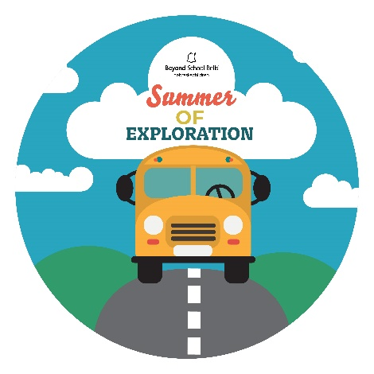Beyond School Bell’s Summer of Exploration 2025 grant competition aims to create memories. We want to support summer programs helping Nebraska’s young people find their interests and build upon their talents through hands on learning and real-world experiences. Building upon *Whole Child, Whole Life* concepts summer grants will incorporate student-centered learning that invests in students’ interests. 2025 applications will be required to incorporate at least one of these student-centered learning approaches:

***Youth Voice and Choice***

Engage students as leaders in programming. [2024 Youth Brainstorming Worksheets](https://beyondschoolbells.org/youth-voice/youth-brainstorming-sheets.html) highlighted (1) Experiential Learning, (2) Sports, and (3) Life Skills as students’ top three past experiences. Use these or apply with brainstorming sheets that show your own students’ voice and choice.

* Experiential Learning such as: Field trips, Fishing, Lemonade stand business, etc.
* Sports such as: Soccer, Group Games, Tournaments
* Life Skills such as: Cooking, How to Make Money, Leadership, How to use tools.

***Community-Connected, Age-Appropriate, Real-World Learning***

Engage and connect students to local opportunities, resources, and careers that give them the opportunity to contribute to their community.

* Connect with and engage local businesses like bakeries or mechanic shops, organizations like Keep Nebraska Beautiful, public libraries, and/or local leaders like elected officials.
* Facilitate Service-Learning experiences to meet real-world needs that students identify and pursue like cleaning up public parks or providing healthy food
* Introduce students to local careers through workplace tours, career talks, career fairs

***Foster Lifelong Learning and Pursuits***

Explore student interests, passions, and purpose they can build on for the rest of their lives.

* Engage students to understand the STEM all around them.
* Build skills and interests that can improve their everyday lives like gardening and cooking
* Develop healthy, life-long habits like movement, outdoor learning, and mindfulness
* Engage families to support students’ interests and identities

Additional information, resources, Request for Proposals, and applications can be found at [www.beyondschoolbells.org](http://www.beyondschoolbells.org). Applications will be due to [dstaggs@nebraskachildren.org](mailto:dstaggs@nebraskachildren.org) and [apearson@nebraskachildren.org](mailto:apearson@nebraskachildren.org) by March 28th 2025.