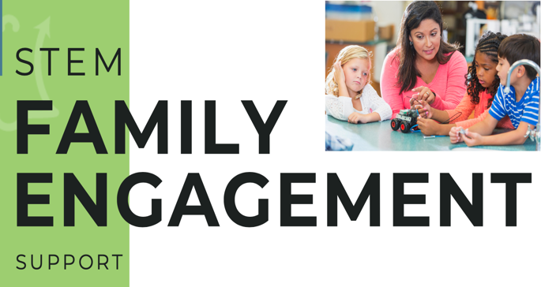

FE Mini-Grant Application Template Tier 1

Name of Program/Site:
Name of Program Director:
Email address:
Phone:
Date:

Beyond School Bells is excited to offer Family Engagement (FE) Mini-Grants beginning in July 2022 for summer and school year support. The purpose is to increase family engagement across NE programs in innovative and hands-on ways that reflect current best practices and a genuine desire for enriching family and community experiences.

FE Mini-Grant Tier 1 Specifications
Please acknowledge commitment to each of the Tier 1 requirements by checking the relevant boxes below:

☐ Staff will become familiar with FE planning workbook and toolkit

☐ Minimum of three staff meetings to discuss FE planning workbook and toolkit

☐ Submit progress (narrative) and expenditure reports at designated dates

Please tell us about the staff members you expect to participate in this project if your program is selected (number will depend on program size, at least 60% of staff should participate in readings and meetings).
☐ List committed staff here:
1.
2.
3.
4.
5.
6.

Acknowledgement
I commit to the above requirements if this application is awarded as a Tier 1 FE Mini-Grant.

Name: _____________ Date: _______________ Signature: ________________

Application Questions:

- Please provide the following information:
  - Enrollment number grant will impact:

  - Grade level(s) grant will serve:

- What experience level would you say your program is at with family engagement?

☐ Beginning (early learning phase)
☐ Intermediate (some developed practices, but would like to grow)
☐ Advanced (highly experienced, very comfortable in current practices)

- Please tell us about how you currently communicate with families:
  - Individual parent/caregiver outreach (select all that apply)
☐ Email
☐ Text
☐ Social Media
☐ Phone
☐ Other:

Frequency of communications:

  - Broad outreach (select all that apply)
☐ Handouts
☐ Flyers
☐ Social Media
☐ Email
☐ Other:

Frequency of communications:

- How many family engagement events does your program currently hold per year?

  - Please describe these events:

- What is your program’s greatest need in terms of engaging families?

- Do you have any additional family engagement ideas/innovations you would like to propose as part of your grant contract?

- Please list three goals for improving your program’s FE practices through the course of this mini-grant:

Goal 1:

Goal 2:

Goal 3:

- What is the total grant amount you are applying for (up to $1,400)?

- Please provide a general budget (ex. Food, STEM materials for FE events, Outreach, etc.).

Send completed applications with general budget proposals to Dakota Staggs dstaggs@nebraskachildren.org and Alison O’Toole aotoole@nebraskachildren.org

