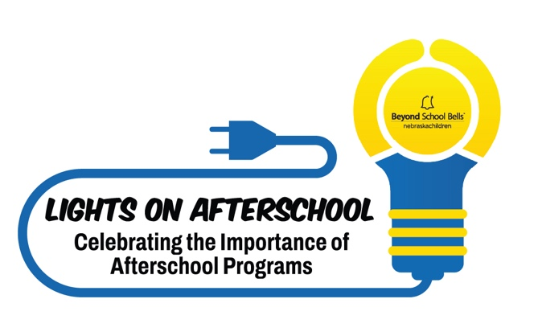
Lights On Afterschool
Funding for a High-Quality Awareness Event

October 2026

APPLICATION

Request for Event Reimbursement
Deadline: Friday, July 31, 2026
Beyond School Bells at Nebraska Children and Families Foundation is pleased to provide reimbursement to afterschool sites for approved expenses associated with hosting a Lights On Afterschool advocacy and awareness event during the month of October to join the nationwide celebration that recognizes the important role afterschool programs play in supporting youth, families, schools and communities.

Submission of Application and Questions
- Submit the application by email to Patricia Sanchez-Stewart at psanchezstewart@nebraskachildren.org no later than Friday, July 31, 2026.
- Questions may be directed to Patricia by email or by phone at 308-325-5438

Applicant Information

Name of Program or Organization and City
Contact Person:
Contact Person Title:
Contact Email:
Total Funding Amount:
Anticipated Date of Event:
Name of Person Coordinating the Event:
Anticipated number of participants who will benefit from the activity or event:
Lights On Afterschool Questions

Describe your Lights On Afterschool event you plan to host in October:

Last October, the Afterschool Alliance released findings from America After 3PM, sharing insights into how kids spend their time after school, who is participating in afterschool programs, and the challenges families encounter. Nebraska-specific data was included in the release.

How will you use America After 3PM or Nebraska After 3PM data during your Lights On Afterschool event to show families, partners and policymakers why afterschool programs are essential in your community?

How will you use your own program-specific data to share with families, partners and policymakers impact being made and to demonstrate the need of your program?

Lights On Afterschool Goals
Please answer the questions for each of the Lights On Afterschool goals:
Raise Awareness
Describe how you will educate event attendees about the benefits of high-quality afterschool programs through activities, displays, statistics or success stories?

What key messages will your presentation include for individuals who may be unfamiliar with your afterschool program or its impact? (Keep in mind a member of the Beyond School Bells team may be available to provide some opening remarks and share data if needed).

Promote Advocacy
In what ways will this event help build relationships with local policymakers, elected officials, community leaders, or other influential stakeholders? Who do you intend to invite?

Describe how youth, families or staff will share stories during the event that demonstrate the importance of continued investment in afterschool programs?

Showcase Quality Programming
What opportunities will guests have to experience or participate in activities that reflect your program’s high-quality programming?

What examples of student learning or program success will be featured during your event?

Increase community engagement
How will your event encourage meaningful participation from community members, organizations, and local businesses?

How will community members have opportunities to learn about, contribute to, or become involved with your afterschool program?

Engage Families
How will your event create meaningful opportunities for families to actively participate rather than simply attend?

How will you gather and incorporate family feedback, ideas or experiences to strengthen your program?

Engage Students
Describe how youth will help make decisions, generate ideas, or organize activities before the event? What leadership roles will students have during the event?

Describe how attendees will see the impact of your program though youth-led demonstrations, performances, exhibits, projects, presentations, videos including youth, stories from youth, etc. ?

Power On Afterschool: Keeping the Lights on Afterschool All Year Long

How will your program “Keep the Lights on Afterschool” beyond the event by sharing program’s story with families, school leaders, policymakers, community partners, and other stakeholders? Describe strategies you will use to continue raising awareness and building support throughout the year.

Event Budget

Budget – Describe what you plan to spend for the event?
*Wages will not be reimbursed through this funding opportunity.

Expense Categories | Amounts | Explanation for Expense
Event Activity Supplies
Outreach Efforts
Promotional Materials
Contracted Services
Other Expenses
 | TOTAL: $

Agreement

I agree to the following:

Participate in three one-hour long meetings as part of the “Lights On Afterschool Capacity-Building Learning Series” virtual learning series.
Dates of required meetings:
Tuesdays-August 18, 12:30-1:30pm
Tuesday, September 15, 12:30-1:30pm
Tuesday, October 6, 12:30-1:30pm

Register my Lights On Afterschool event through Afterschool Alliance

Allow a member of the BSB evaluation team to attend event and use an observation tool to capture information

Provide Beyond School Bells 2-3 photos of event with media permissions

Complete a narrative report via a Qualtrics link provided by Beyond School Bells within two weeks of your event.

Record participation counts of groups (students, families, staff, community members, partners, or leaders)

Submit an invoice to Beyond School Bells by December 15, 2026 for reimbursement of approved expenses

Signature: type your name here | Date:

Resources

America After 3pm

Afterschool Alliance: Lights On Afterschool

