Grow NE Gardening Tracks Overview

Beyond School Bells is excited to announce the continued support for Grow NE in 2025-26 afterschool programs. Grow NE is a program that supports afterschool and summer Expanded Learning Opportunities related to Food Systems – gardening, agriculture, local foods, and so much more. Grow NE contracts and technical assistance are offered to support high school student leadership of afterschool and summer clubs and activities. BSB has designed 4 track frameworks to help structure and provide support for your Grow NE programming this year.

Within each track, we will provide structured support for HS student leaders to address local food system challenges and give suggested weekly lessons/activities for them to lead with K-8 students. This year, BSB will offer direct support to connect your students with resources, community members, and career experts related to the track of your choosing. The 4 track options are: **Innovative Agriculture, Local Food Systems, Sustainable Growing, and Afterschool to Table.**

We chose these 4 tracks specifically to align with the Grow NE goal of empowering Nebraska's young leaders to engage in and become leaders of local food systems. The **innovative agriculture** track is set up to engage students not typically interested in their local food system via technology and experimentation. The **local food systems** track guides students through what a local food system is, why they’re important, and how they can connect to their local food system. The **sustainable growing** track intends to instill the value of nature and ecology on local food systems. The **afterschool to table** track enables students to bring their local food system to the afterschool space and to their classrooms. Choosing the track that fits your programming best but still fits into the local food system lens is our hope here!

Clubs can be **quarterly** or by **fall**, **spring**, **summer**, or a **combination** of the three

Clubs must include:

* Participation in the [National Geographic Slingshot Challenge](https://www.nationalgeographic.org/society/projects/slingshot/)
* HS student leadership
* Peer engagement

We will support your Grow NE programming by assisting with technical questions, growing questions, youth leadership support, national geographic slingshot challenge support, and by connecting your club to relevant careers, farms, partners experiences. We can also provide a flexible club guide including a week by week structure and more resources and ideas on lessons/activities/supplies!

Choose from:

* **Innovative Agriculture** if you’d like to utilize hydroponics or indoor gardening in your classroom!
* **Local Food Systems** if you’d like to teach your students about their local food system and the agriculture around them!
* **Sustainable Growing** if you’d like to emphasize nature and ecology when gardening with your students!
* **Afterschool to Table** if you’d like to engage your students in the seasonality and preparation of local foods!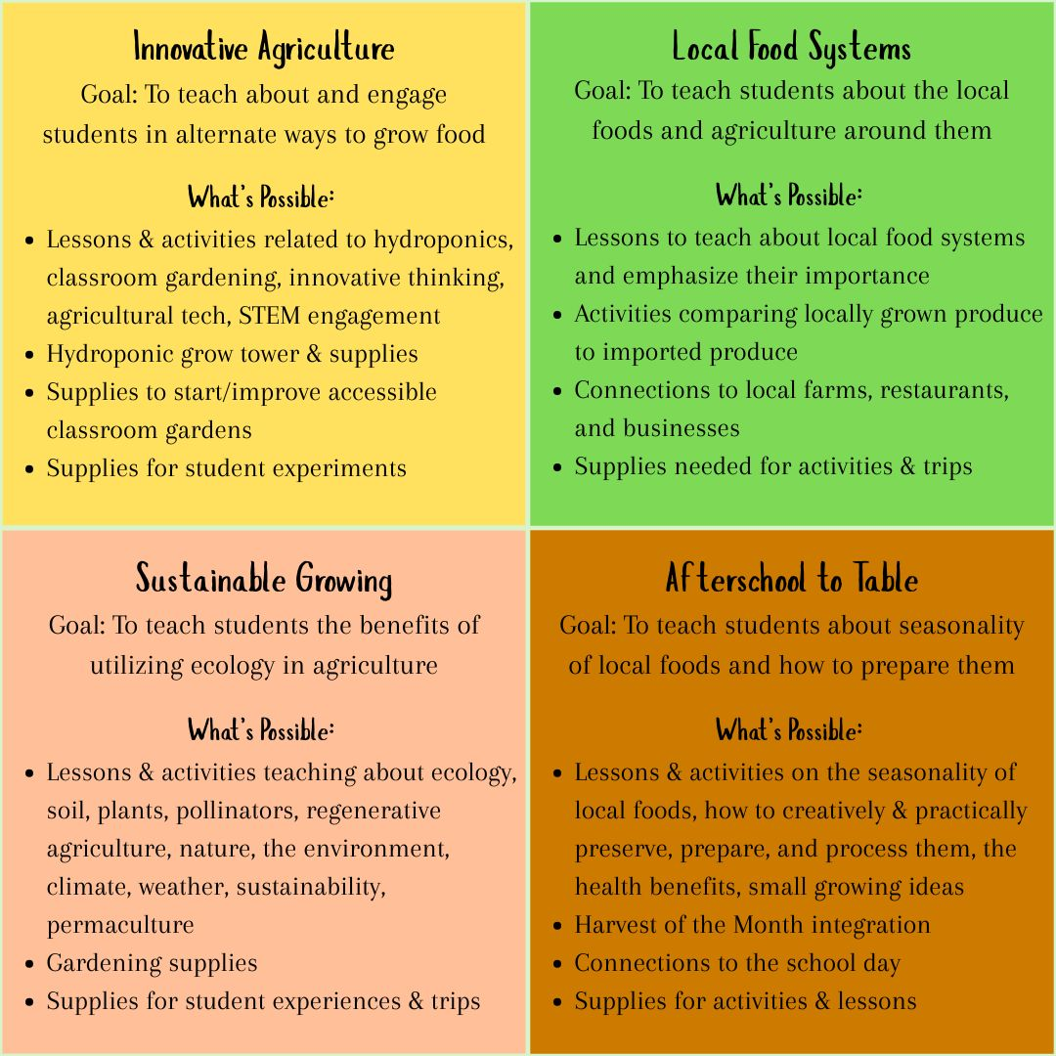

**Innovative Agriculture**

There is not just one way to grow food, explore this track to engage students in innovative ways to grow food locally throughout the year using STEM and creativity. Programming in this track can include growing with a hydroponic tower, in greenhouses or aquaponics, or using high-tech agricultural technology like the Flex Farm or soil sensors!

***Learning Goal: To introduce youth to new and engaging ways of growing food.***

Here are some resources for the Innovative Agriculture track [Camp & Club Guides – Nebraska Farm Bureau Foundation](https://nefbfoundation.org/camp-guides/) (Let’s Get Growing) and [Exploring Hydroponics: A Classroom Lesson Guide](https://www.farmtoschool.org/resources-main/exploring-hydroponics-a-classroom-lesson-guide) (There are many great lessons in here that can cater to many interests and learning objectives). Each of those resources include lessons and hand on activities to go with them! Some examples of what we could fund for this track are a hydroponic grow towers & supplies and a field trip to a local hydroponic farm!

Why choose this track?

* If you’re looking for creative and fun ways to engage kids to food systems/gardening who aren’t predisposed to going outside and gardening
* To engage students in gardening through STEM and the opportunity for experimentation
* To extend your growing season

**Local Food Systems**

Functioning local food systems are essential for sustainable, healthy, and happy communities. Explore this track to emphasize where food comes from, the importance of local food systems, and how your students can be a part of their local food system.

***Learning Goal: To engage youth in local food systems and connect them to local agriculture.***

Here are some resources for the Local Food Systems track [NDE’s Farm to School Harvest of the Month,](https://www.education.ne.gov/ns/farm-to-school/harvest-of-the-month/#1686152539965-a8a4205e-1f1a) [Home - Walk to Unlock Nebraska,](https://walk2unlock.ne.gov/) and [Programs | UNL Food | Nebraska.](https://food.unl.edu/programs/) An example lesson/activity for your club could be choosing a food item to explore, learn about, and engage with using the provided Harvest of the Month materials. Lessons, handouts, activities, and possible procurement methods are included. Some examples of what we could fund for this track would be the local food your students are exploring, the supplies needed to do the activities, and a field trip to a local farm that grows the food item.

Why choose this track?

* To instill value in local food systems starting at a young age
* To cultivate knowledge and interest in eating healthy and sustainably

**Sustainable Growing**

Nature is a part of us and increases our overall wellness, explore this track to teach students how nature increases the overall wellness of gardens as well! Sustainable Growing is designed for students to explore the world of regenerative agriculture and view gardening through the lens of ecology.

***Learning Goal: To introduce youth to the benefits of utilizing ecology in agriculture.***

Here are some resources for the Sustainable Growing track [Kiss the Ground](https://kisstheground.com/education/resources/childrens-education/#gradelevel) and [Regenerative Farmers of America.](https://www.regenerativefarmersofamerica.com/childrens-educational-resources-for-regenerative-agriculture) An example lesson/activity for your club could be reading ‘The Little Regenerative Farmer’ with your class and then using the supplemental regenerative agriculture principles coloring sheets. Some examples of what we could fund for this track would be purchasing the book and coloring books and a field trip to a local regenerative farm that uses the principles they learned about.

Why choose this track?

* To get your students outside and learning hands on in the garden
* To see firsthand how outdoor learning/nature can impact kids
* To teach students about ecology/life sciences in a different way

**Afterschool to Table**

If you have an existing cooking club or are looking to teach students important life skills, explore this track to introduce kids to the seasonality of food, culinary skills, and how they can help prepare food for their classmates!

***Learning Goal: To teach students about seasonality of local foods and how to prepare them, ultimately engaging youth in Farm to School efforts.***

Here are some resources for the Afterschool to Table track [NDE’s Farm to School Harvest of the Month,](https://www.education.ne.gov/ns/farm-to-school/harvest-of-the-month/#1686152539965-a8a4205e-1f1a) [UNL 4H’s We Cook,](https://marketplace.unl.edu/extension/wecook-curriculum.html) and [Programs | UNL Food | Nebraska.](https://food.unl.edu/programs/) An example lesson/activity for your club could be doing some activities from the We Cook curriculum and then sharing what they learned and prepared with their class the next day! Some examples of what we could fund for this track would be purchasing the curriculum, food items, and supplies necessary for the activities and then the materials needed to host a family event to share the knowledge with their community.

Why choose this track?

* To give students the knowledge and skills to grow, process, and prepare their own food
* Engage students in a fun and creative outlet while gaining life skills
* Provide an opportunity to build confidence in students

[**National Geographic Slingshot Overview**](https://www.nationalgeographic.org/society/projects/slingshot/)

1. Guage student interest-- what passions, problems, challenges do the students in the club have surrounding the environment, climate change, and/or sustainability that fall into the following categories?
   1. CLEAN THE AIR
   2. RESTORE THE OCEAN
   3. PROTECT NATURE
   4. REDUCE WASTE
   5. ADDRESS CLIMATE CHANGE
2. Research and brainstorm with the students on ideas of how to address their challenge
3. Research more about the challenge, solution, and its impact on their communities
4. Plan and record the one-minute video which will be used to tell the story of the student's ideas and solutions for their community
5. Submit the video and try to engage students in the action chosen via their club pathway

***Guides and worksheets will be provided as well as direct BSB support.***