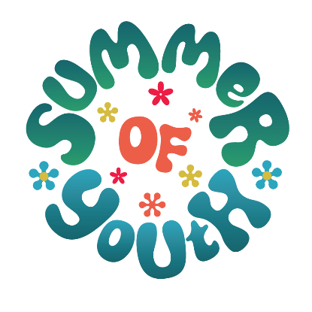
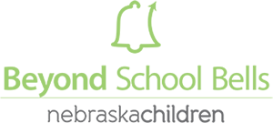

Summer of Youth 2023 Grant Overview
The Summer of Youth 2023 represents a unique opportunity for summer learning programs across Nebraska to create enriching, impactful, and lasting experiences for our youth. BSB and NDE utilized a statewide student brainstorming process to identify youth interests and using this input created a set of criteria directly based on what we have heard Nebraska youth say they value: Sports and Movement, Experiential learning, and Life skills. See the BSB website to access the full report. All 2023 grants will be required to incorporate youth-voice for programming choices and plans.
Building on this insight, the criteria described below will be used to evaluate applications in one of three summer grant categories: Movement and Outdoor Learning, Life Skills and Career Pathways, and Experiential Learning via Local Partnerships.
- Movement and Outdoor Learning – programming that allows youth to engage in outdoor, hands-on, experiential activities. Some examples include:
- Sports and movement-based activities
- Outdoor Classrooms and gardens
- Environmental Service, including Great Plains Conservation efforts
- Life Skills and Career Pathways– engage your youth to identify exciting, engaging, and inspiring programs that they what to do.
  - Entrepreneurship and Career Exploration
  - Science, Technology, Engineering and Math (STEM)
  - Cooking and healthy lifestyles

- Experiential Learning via Local Partnerships – engage local organizations, initiatives, and/or projects and provide opportunity for youth to impact local community.
  - Partnerships with local businesses or professionals (ex. Grocers, Bankers, Chefs…)
  - Local environmental projects such as Civic Nebraska’s “Environmental Playground”
  - Partnerships can be unique to communities and programs

Summer of Youth 2023 Grant Request for Proposal
Summer Grant Details:
- Applications due to BSB by March 31st without exception
- Required evidence of Youth Voice criteria
  - Either selection of BSB and NDE data OR site-created Youth Brainstorming sheet
- Applications will require a detailed budget
  - Staffing, Field Trips, Supplies, Services
  - Budgets must comply with ESSER budget guidelines
  - Non-ESSER eligible expenses must be requested separately (MUST be an additional budget form)
- Eligible applicants
  - All ESSER Funded Afterschool and Summer programs
  - 21st Century Community Learning Center sites
  - School-based Summer ELO programs
- Required letter of support from superintendent or principal
- Grants will be administered on a monthly reimbursement basis (exceptions will be permitted on a case by case basis)
Grant applicants should incorporate the following in their programming proposal:
- Details showing how you have incorporating youth-identified activities to inform your application. Programs may utilize the priorities identified in our report OR work with their students to create their own Youth Brainstorming Sheets to identify specific local criteria.
- Align your ELO program with your district’s goals for summer experiences that complement but not duplicate school-year activities
- Engage youth in community-based learning – bringing in community expertise and getting youth out into the community
- Should include, where possible, STEM, including Tech and other tool-rich experiences, connections to future learning / careers, support for student and staff wellbeing, activities that get youth outdoors and moving
Ideas for a successful application:
- Tap into BSB Centers of Excellence for guidance / advice / strategies
- Use our BSB Curriculum / Toolkit to facilitate programming and engage your community
- Use a blended learning approach – learning while having fun
- Engage older youth as leaders and mentors in programming, HS Students as facilitators, College students as content experts
- Use our sample proposal templates (attachment to RFP) to jump start your program.
- Reach out to BSB for questions, collaboration, or advice
Evaluation Requirement
- Before the end of programming, student and facilitator/educator surveys must be administered one time to participating students and facilitators/educators
- Required progress and narrative reports due to BSB on or before September 31st 2023
- Talk to BSB for deeper dive evaluation/storytelling options around summer experiences at your program
- At least one youth-directed evaluation such as Youth Videography, Student-authored summer story book, etc.
Reach out to Dakota Staggs, dstaggs@nebraskachildren.org, or your BSB point-person with questions or concerns. We look forward to hearing from you!

