**Jeopardy**

**Setting up the stage:**

This is just normal jeopardy. The emphasis here is on repetition/practice so make sure all group members participate. This activity works best on ACT math

Note: Ask students to write down problems they struggled with for their own review later

**Resources/Materials**

* [ACT: MATH](https://jeopardylabs.com/play/act-math-51)
* Timer
* Zoom

**Facilitators Guide**

1. Create Groups of 2-3 students
2. Open the [jeopardy board](https://jeopardylabs.com/play/act-math-51) and share your screen
3. Have groups decide on names or number them
4. Give each group 60-90 seconds to solve the problem
5. Ask the group to submit their multiple-choice answer
6. 1 point for the correct answer. 2 points for explanation
7. Repeat

**Bingo**

**Setting up the stage:**

This activity is a basic bingo game with slight modifications requiring students to answer/explain questions for points. This activity works best on ACT math.

Note: Ask students to write down problems they struggled with for their own review later

**Resources/Materials**

* Link to [bingo boards](https://myfreebingocards.com/bingo-card-generator)(printable or google docs)

|  |  |
| --- | --- |
| 0.0004 p1 | 3/13 |
| 75 in^2 | x^6 p2 |

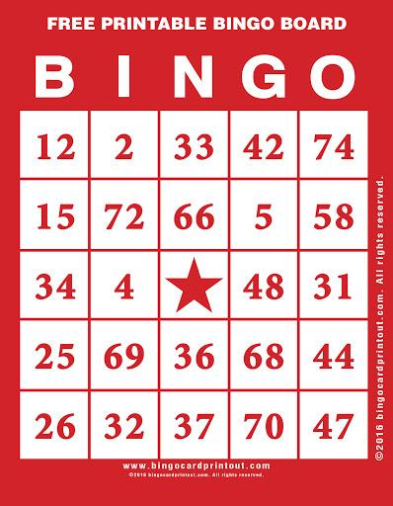

* Act Math Questions and answers
* Timer
* Zoom

**Facilitators Guide**

1. Create Groups of 5 students (Number of group members should match # of squares required to win bingo)
2. Assign each group 1 bingo board
3. Open the [questions](https://www.analyzemath.com/practice_tests/act/act_sample_1.html) and [solutions](https://www.analyzemath.com/practice_tests/act/act_sample_1_solution.html) in two different tabs
4. Share the tab with the questions
5. Instead of using an X ask students to write the problem number in the bingo square
6. Give students 60-90 seconds per question and wait till bingo
7. Ask the problem numbers and verify the answers. Award 1 point for the correct answer and 2 for a correct explanation.

* Important: One student per answer/explanation.

1. Award prize and repeat

**Robbery**

**Setting up the stage:**

The emphasis here is on repetition/practice so make sure all group members participate. This activity works best on ACT math. The basic concept is groups steal points from other groups based on how many questions (of 5) they get correct.

Note: Ask students to write down problems they struggled with for their own review later

**Resources/Materials**

* Act questions divided into groups of 5
* Timer
* [Tally Counter](https://tallycounterstore.com/online-counter)
* Zoom

**Facilitators Guide**

1. Create Groups of 2-3
2. Open [Tally Counter](https://tallycounterstore.com/online-counter) and create one for each team
3. Share 5 questions over zoom
4. Give students 5 min
5. Share answers on zoom and ask groups how many questions they got right
6. Determine 1st, 2nd and 3rd place groups
7. Start with the 1st place team. They can answer up to 3 questions to earn points

* Correct answer = 1 points
* Correct explanation = 1 points

1. Tally up their total points ( answer + explanation). They can steal that number of points from any team.
2. Go to the 2nd place team and repeat. They can answer the rest of the questions.
3. If 2nd place can only provide correct answers with no explanation (Each answer = 1 point) then the third-place team can provide explanations for the unclaimed points
4. Repeat