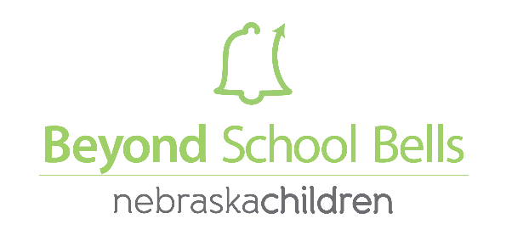

Application for 2021 Summer Innovation Grant
Name of School-Based Summer Program Click here to enter text.
Name of Director Click here to enter text.
Email Address Click here to enter text.
Phone Number Click here to enter text.

- What category grant are you applying for (check the box)
- Environment / Conservation Programming
  - Gardening
  - Outdoor Classrooms
  - Community-generated ideas for environmental activities)
- Youth Driven Programming
- Service- Learning / Civic Engagement programming

- What is the total Summer Innovation grant amount that you are applying for (up to $15,000)?
Click here to enter text.

- What is your current afterschool enrollment for your program? What do you expect summer enrollment to be for your program in summer 2021? What grade levels does your summer program serve? Click here to enter text.

- When will your summer program be offered--include days of week/hours, as well as dosage (hours): Click here to enter text.

- Please outline your proposed summer programming for this grant. Include specifics about the programming and implementation plan. If you are applying for “Youth-Drive Programming”, please outline how youth voice has driven your proposal (how did you get youth ideas, buy-in). Click here to enter text.

- What is your plan for your summer staffing structure for the proposed programming (teachers, paras, high school/college students)? Click here to enter text.

- Brief description of any community partner(s) that will be involved in this programming and what role(s) they will play in supporting your programming this summer and long-term. Click here to enter text.

- With support from this grant:
  - What is the total number and age range of students you would like your program to serve specific to this proposed summer programming? Click here to enter text.

  - List 2-3 goals you would you like to see accomplished at the completion of this grant. Click here to enter text.

- BUDGET JUSTIFICATION: outline budget items and provide brief explanation

- BUDGET: Please itemize expenses in budget for your proposed programming/grant proposal
Budget Item | Price for each | Total | Notes/URL
Total Grant |  | $

*If you are utilizing the sample proposals (Attachments A, B, C, D), please make adjustments to these proposals/budgets to reflect your specific program.

Please attach one letter of support from a School District administrator (Superintendent or Building Principal).

Applications are due by 5:00 PM CST on April 1, 2021. Completed applications include:
(1) Grant Application
(2) Proposed Budget Justification and Budget (included in application)
(3) Letter of Support from School Superintendent or Principal.

Email completed application to Dakota Staggs at dstaggs@nebraskachildren.org.

