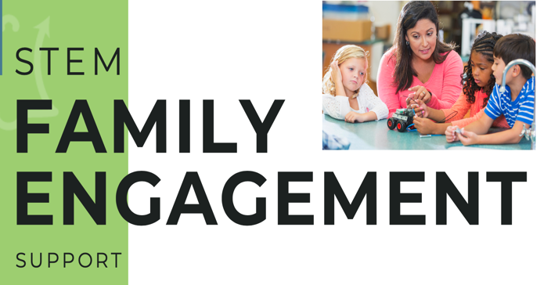

FE Summer Grant Application

Name of Program/Site:
Name of Program Director:
Email address:
Phone:
Date:

Beyond School Bells is excited to offer Family Engagement (FE) Mini-Grants beginning in July 2022 for summer and school year support. The purpose is to increase family engagement across NE programs in innovative and hands-on ways that reflect current best practices and a genuine desire for enriching family and community experiences.

Please select which summer grant option you are applying for:
☐ Community-wide end of summer afterschool program celebration
☐ Develop communication materials to share with caregivers as summer camp/club progresses
☐ Add or enrich family engagement event as end of summer club/camp experience
FE Summer Grant Specifications
Please acknowledge commitment to each of the summer grant requirements by checking the relevant boxes below:

☐ If applying for an event option, we will incorporate a STEM activity for families to do together at event (if not applying for event option, leave box unchecked)

☐ Submit progress (narrative) and expenditure reports at end of contract

Acknowledgement
I commit to the above requirements if this application is awarded as FE summer grant.

Name: _____________ Date: _______________ Signature: ________________

Application Questions:

- Please provide the following information:
  - Enrollment number grant will impact:

  - Grade level(s) grant will serve:

- What level of experience would you say your program is at with family engagement?

☐ Beginning (early learning phase)
☐ Intermediate (some developed practices, but would like to grow)
☐ Advanced (highly experienced, very comfortable in current practices)

- Please tell us about how you currently communicate with families:
  - Individual parent/caregiver outreach (select all that apply)
☐ Email
☐ Text
☐ Social media
☐ Phone
☐ Other:

Frequency of communications:

  - Broad outreach (select all that apply)
☐ Handouts
☐ Flyers
☐ Social media
☐ Email
☐ Other:

Frequency of communications:

- How many family engagement events does your program currently hold per year?

  - Please describe these events:

- What is your program’s greatest need in terms of engaging families?

- Do you have any additional family engagement ideas/innovations you would like to propose as part of your grant contract?

- Please list three goals for improving your program’s FE practices over the course of this mini-grant:

Goal 1:

Goal 2:

Goal 3:

- What is the total grant amount you are applying for (up to $1,500)?

- Please provide a general budget (ex. Food, STEM materials for FE events, Outreach, etc.).

Send completed applications with general budget proposals to Dakota Staggs dstaggs@nebraskachildren.org and Alison O’Toole aotoole@nebraskachildren.org

