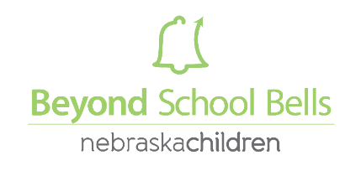
2020 Incubator Grant Application: New Program

PART I – PROGRAM NEED

- Briefly describe your school and the community you serve. Click here to enter text.

- Please check all applicable boxes below if applicable to your school/program:

Title I School | Identified by NDE as Needs Improvement
Previously had an afterschool program | No other academically enriched afterschool program is available in our community
Previously had a summer program

- Has your school/community conducted an informal or formal needs assessment to identify the need/s for programming? If so, please briefly outline the findings. Click here to enter text.

- Please indicate below the stakeholders in your school/community that have expressed support of a new afterschool program:
Superintendent | Community Members
School Board Members | Local Business/es
School Administrator/s | City Government (mayor, city council)
Teachers | Police
Parents | Local Extension/4-H

- Briefly explain the vision driving your community’s interests in starting an afterschool and summer program. Click here to enter text.

PART II – PROGRAM DESCRIPTION

- Provide a general overview of the type/s of programming you would like to offer in your afterschool and summer program (Robotics, STEM, Service Projects, Arts, Gardening, etc.): Click here to enter text.

- AFTERSCHOOL PROGRAMMING: Indicate below the days/hours your program plans to operate.
Monday | Tuesday | Wednesday | Thursday | Friday

- SUMMER PROGRAMMING Indicate below the days/hours your program plans to operate.
Monday | Tuesday | Wednesday | Thursday | Friday
Number of weeks:

- How many students will be served?
 | Afterschool | Summer
Number of students to be served:
Grades to be served:

PART III – BUDGET

What is your estimate of program costs? Please enclose an annotated budget proposal (Attachment C) that briefly outlines (1) the proposed programming expenses and (2) how local resources (both cash and/or in-kind) from your local partner/s will be used to leverage grant funds for the programming described in the grant application.

In developing your initial program budget, we strongly encourage you to visit the Beyond School Bells ELO Toolkit Funding Structures section for sample budgets and funding sources.

PART IV – COLLABORATIVE RESOURCES

Name(s) of Local Partner(s) providing matching financial contribution/s. Please also include amount/s of contribution, this includes in-kind contributions. Click here to enter text.

Give a brief description of the Partner(s) and what role they will play in supporting your programming. Click here to enter text.

*Please attach two letters of commitment from (1) local partner/s identified above and (2) a School District administrator.

